|  |  |  |  |  |
| --- | --- | --- | --- | --- |
| **National University of Computer and Emerging Sciences, Lahore Campus** | | | | |
| final design | **Course:** | **OOAD Lab** | **Course Code:** | **CS-309** |
| **Program:** | **BS(Computer Science)** | **Semester:** | **Fall 2018** |
| **Duration:** | **90 minutes** | **Total Marks:** | **50** |
| **Quiz Date:** | **13-Nov-2018** | **Weight** | **5** |
| **Section:** | **F** | **Page(s):** | **2** |
| **Exam:** | **Quiz 1** | **Roll No:** |  |

**If you find any confusion in the statement, make suitable ASSUMPTIONS and mention it as comment at the start of your code. Do not ask your instructor.**

**Question # 1 (50) (Through Drag and Drop UI components)**

**Exercise 1:** Create the following GUI for a student information system using java swing components.

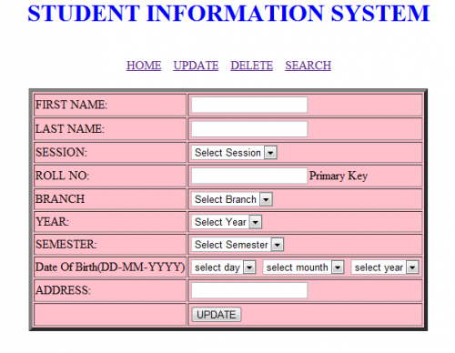

**Exercise 2:** Create a class Student having following data members.

* Firstname
* LastName
* Session
* RollNumber
* Branch
* Year
* Semester (integer between 1 to 8)
* Date of birth
* Address

Now create an class with name as Record Student. This class has the following data members.

* List<Student > students
* int count_of_Students

**Functions**

1. Boolean Add_Student (Student m)

* This function will take student object and add them to the list.
* Returns true in case of success.

1. Boolean Delete_Student (String Rollnumber)

* This function will take student rollnumber and search for it in the list and delete the record in case of record found and return true.

1. Boolean Search (String Rollnumber)

* This function will take student rollnumber and search for it in the list and if found returns true.

**Exercise 3: (Event Handling)**

For the GUI you have built in task 1 you have to implement event listeners for buttons update, delete and Search using task2 functions you have implemented.